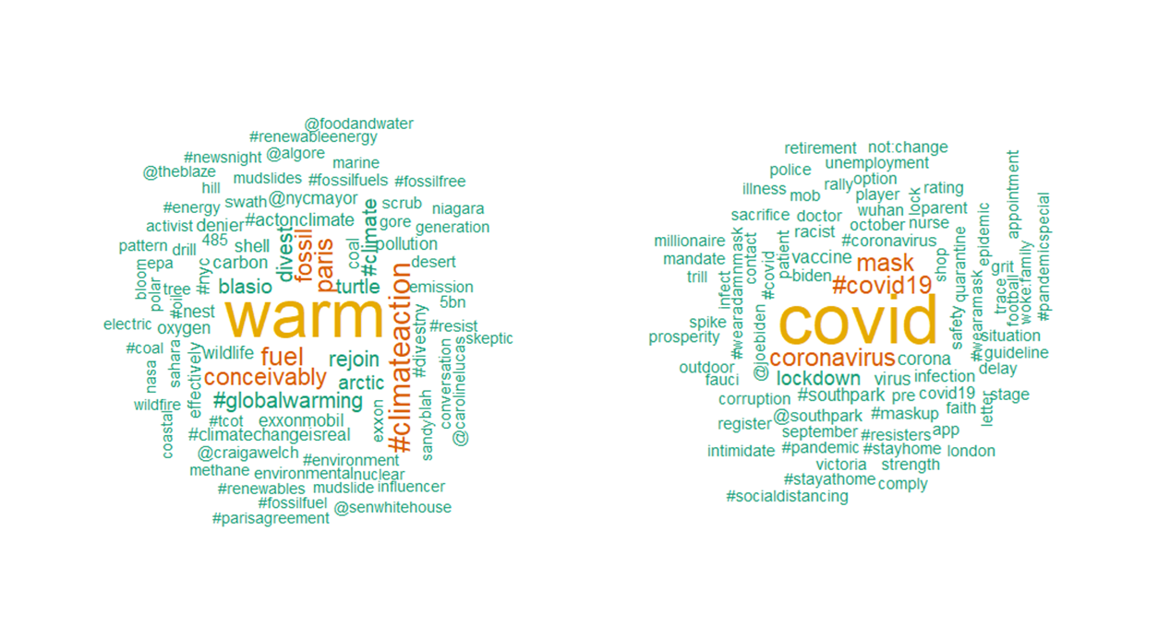Figure X. Words that best distinguish between tweets about climate change and tweets about covid-19 (using TF-IDF scores). Tweets were sampled in October of 2018 and October of 2020 respectively. See the supplemental guides for code.